**CHAPTER 1**

# INTRODUCTION

Evapotranspiration (ET) is a process which includes loss of water from the plant as well as soil surface into the environment. Evapotranspiration (ET) is the combined processes which move water from Earth's surface into the [atmosphere](https://en.wikipedia.org/wiki/Atmosphere_of_Earth). It covers both water [evaporation](https://en.wikipedia.org/wiki/Evaporation) i.e. movement of water to the air directly from soil, [canopies](https://en.wikipedia.org/wiki/Canopy_interception), and water bodies and [transpiration](https://en.wikipedia.org/wiki/Transpiration) i.e. evaporation that occurs through the stomata, or openings, in plant leaves. Evapotranspiration is an important part of the local [water cycle](https://en.wikipedia.org/wiki/Water_cycle) and [climate](https://en.wikipedia.org/wiki/Climate), and measurement of it plays a key role in [agricultural irrigation](https://en.wikipedia.org/wiki/Irrigation) and [water resource management](https://en.wikipedia.org/wiki/Water_resource_management). Evapotranspiration is a crucial variable for hydrological and agro-meteorological investigation in order to optimize water consumption in agricultural sector. Evapotranspiration is a combination of two dynamic processes viz. evaporation and transpiration. A special consideration is given to crop evapotranspiration, further defined under standard and non-standard conditions (FAO).

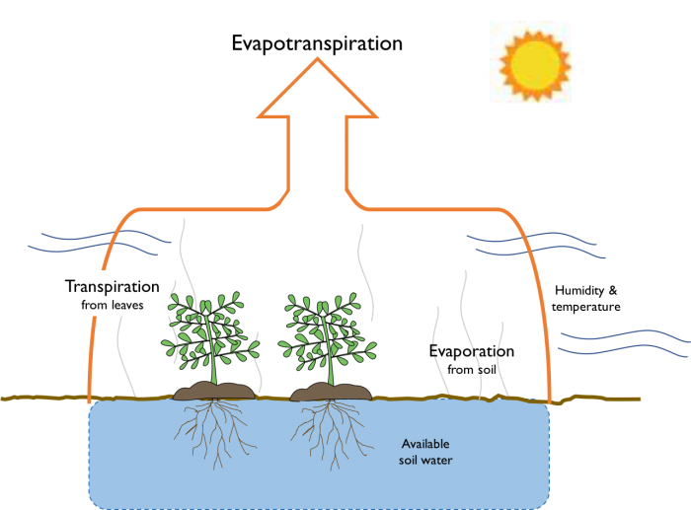

Fig 1.1 Illustration of Evapotranspiration Process in Nature

Adequate water availability is essential to ensure the sustainability of the environment and the various human activities. Therefore, their sustainable management is necessary, as water is a finite resource in quality and quantity. The irrigated agriculture accounts for about 70% of

all freshwater used by humans. Thus, it is necessary to study the water demand of crops. The most relevant component of the terrestrial phase of the hydrological cycle is evapotranspiration (ET), which is crucial for the management of water resources.

Evapotranspiration (ET) is a critical component of the Earth's water cycle, representing the combined processes of evaporation from soil and water surfaces and transpiration from plants. It plays a pivotal role in various environmental processes, including water resource management, agricultural productivity, climate dynamics, and ecosystem functioning. Accurate estimation of ET is essential for understanding hydrological processes, optimizing water management practices, and mitigating the impacts of climate change on water resources and ecosystems.

Traditional methods for estimating ET, such as empirical equations and physical models, often rely on complex mathematical formulations and require extensive input data, making them computationally intensive and challenging to apply over large spatial and temporal scales. In recent years, machine learning techniques have emerged as promising alternatives for predicting ET, leveraging advancements in computational power, data availability, and algorithmic sophistication.

Machine learning offers the potential to develop data-driven models that can capture complex relationships between meteorological variables, land surface characteristics, and ET dynamics. By training machine learning algorithms on historical data, these models can learn patterns and correlations, thereby enabling the prediction of ET with improved accuracy and efficiency. Additionally, machine learning approaches can adapt to changing environmental conditions and incorporate non-linear relationships that may be challenging to capture using traditional methods.

In this project, we aim to develop and evaluate machine learning-based models for the prediction of evapotranspiration across different spatial and temporal scales. By harnessing diverse datasets containing meteorological observations, remote sensing data, and land surface parameters, we seek to build robust predictive models capable of estimating ET under varying climatic and environmental conditions. Through comprehensive validation and verification exercises, we will assess the performance of these models and identify opportunities for refinement and improvement.

* 1. **Overview**

Evaporation parameters are being used in studying water balances, water resource management, and irrigation system design and for estimating plant growth and height as well. Evapotranspiration is measured by different methods by using various parameters. Evapotranspiration is one of the most important components of water cycle, and is a key factor for agriculture, irrigation scheduling and water resources. It can be measured directly using micrometeorological techniques based on energy balance and water vapor mass ﬂux transfer methodologies, however, it is much cost. Accurate and quick prediction of potential evapotranspiration will help to analyze environmental change, and be necessary and extremely important for crop irrigation, irrigation water dispatch, water resources management in river basins, ecological environment assessment, water resources balance research at different scales and hydrological and ecosystem model modelling. Reference evapotranspiration (ETo) is a fundamental parameter for hydrological studies and irrigation management. The Penman-Monteith method is the standard to estimate ETo and requires several meteorological elements.

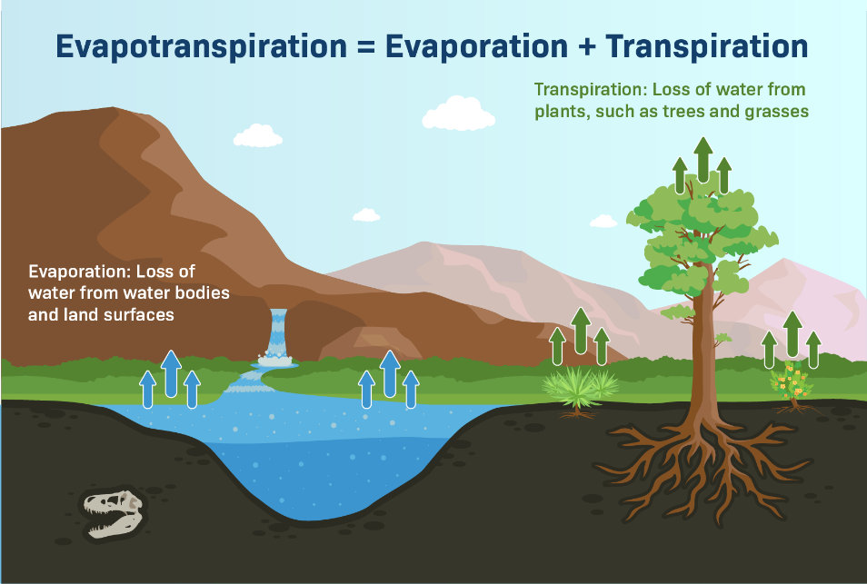

Fig 1.2 Evapotranspiration Process In Nature

Accurate assessment of evapotranspiration is of vital importance from different points of view, such as reliable quantification of hydrological water balance, hydrological design, water resource planning and management, irrigation system design and management, and crop yield simulation. In this study actual evapotranspiration, as an individual hydrological process is of

interest to be modelled, estimated, and analysed.

The realization of the evapotranspiration process, which is obtained through an understanding of the temporal variations of AET (actual evapotranspiration) time series and the meteorological variables influencing the AET, can be considered as a step forward in the global aim of better understanding and management of irrigation scheduling. Water management has been repeatedly emphasizing on scientific irrigation scheduling.

1. **Need of the Evapotranspiration**

Predicting evapotranspiration (ET) using machine learning can offer several advantages and address various needs:

1. **Improved Water Resource Management:** ET prediction helps in managing water resources more efficiently by providing insights into the water demand of vegetation and the soil. This is crucial for agriculture, urban water supply systems, and ecosystem management.
2. **Climate Change Adaptation**: With climate change impacting precipitation patterns and temperatures, accurate ET prediction can assist in adapting agricultural practices and water allocation strategies accordingly.
3. **Optimizing Irrigation Scheduling:** Predicting ET can aid in optimizing irrigation scheduling by providing farmers with real-time or forecasted ET rates, helping them decide when and how much to irrigate their crops to maximize water use efficiency.
4. **Energy Management:** ET prediction can also be valuable in the management of energy resources, especially in hydropower generation, where accurate estimates of water availability are essential for planning electricity generation.
5. **Environmental Monitoring:** Monitoring ET helps in assessing ecosystem health, understanding land-atmosphere interactions, and studying the impact of land-use changes on regional climates.
6. **Drought Prediction and Management:** ET prediction can contribute to early detection and monitoring of drought conditions by assessing water loss from soil and vegetation, helping authorities and stakeholders to implement timely mitigation measures.
7. **Remote Sensing Integration:** Machine learning algorithms can leverage remote sensing data (e.g., satellite imagery, weather data) to improve the accuracy of ET predictions, enabling large-scale monitoring and analysis of ET dynamics over different landscapes.
8. **Forecasting Agricultural Productivity:** Accurate ET prediction can contribute to forecasting agricultural productivity by estimating crop water requirements and predicting yield potentials based on water availability.

**1.3 Where It Can Be Installed**

The prediction of evapotranspiration (ET) using machine learning can be implemented in various settings and platforms, depending on the specific application requirements and available resources. Here are some common deployment options:

1. **Desktop Applications:** Machine learning models for ET prediction can be deployed as desktop applications, allowing users to input relevant data (such as meteorological variables, soil properties, vegetation characteristics) and obtain ET predictions as output. These applications can be developed using programming languages like Python, Java, or R, utilizing frameworks such as TensorFlow, scikit-learn.
2. **Web Applications:** ET prediction models can be integrated into web-based applications, accessible through web browsers. Users can input data through a web interface, and the application can provide ET predictions in real-time or on-demand. Web frameworks like Django, Flask, or Node.js can be employed for building such applications.
3. **Mobile Applications:** Mobile apps can be developed to provide ET predictions on smartphones and tablets. This can be particularly useful for farmers and agricultural professionals who need on-the-go access to ET information for irrigation management and decision-making. Mobile development frameworks like React Native, Flutter, or Swift can be utilized for building cross-platform or native mobile apps.
4. **Cloud-Based Services:** ET prediction models can be deployed as cloud-based services, allowing users to access them over the internet without the need for local installation or maintenance. Cloud platforms such as Amazon Web Services (AWS), Google Cloud Platform (GCP), or Microsoft Azure offer infrastructure and services for deploying machine learning models, enabling scalability and accessibility.
5. **Embedded Systems:** In some cases, especially for applications requiring real-time ET predictions in remote or resource-constrained environments, machine learning models can be deployed on embedded systems or IoT (Internet of Things) devices. These systems can collect data from sensors and other sources, process it locally, and provide ET predictions autonomously.
6. **APIs (Application Programming Interfaces):** ET prediction models can be deployed as APIs, allowing other software applications to integrate ET prediction functionality seamlessly. Developers can access the ET prediction service through API endpoints, passing input data and receiving predictions as JSON or XML responses.
7. **GIS (Geographic Information System) Integration:** For applications involving spatial analysis and mapping, ET prediction models can be integrated into GIS software such as ArcGIS, QGIS, or Google Earth Engine. This allows users to visualize and analyse ET patterns spatially and perform geospatial analysis alongside other spatial data layers.

**1.3.1 Who Can Use It**

The prediction of evapotranspiration (ET) using machine learning can be valuable to a diverse range of stakeholders and professionals across various sectors. Here are some examples of who can benefit from utilizing ET prediction models:

1. **Agriculturists and Farmers:** Farmers can use ET prediction models to optimize irrigation scheduling, ensuring that crops receive the right amount of water at the right time. This helps in conserving water resources, reducing water stress on crops, and maximizing crop yields.
2. **Water Resource Managers:** Water resource managers can utilize ET prediction models to assess water demand from vegetation and soil, aiding in the efficient allocation and management of water resources for agricultural, municipal, industrial, and environmental purposes.
3. **Environmental Scientists:** Environmental scientists can leverage ET prediction models to study ecosystem dynamics, land-atmosphere interactions, and hydrological processes, contributing to better understanding and management of natural resources and ecosystems.
4. **Climate Scientists:** Climate scientists can use ET prediction models to assess the impacts of climate change on water availability, vegetation dynamics, and regional climates, aiding in climate change adaptation and mitigation efforts.
5. **Hydrologists and Water Engineers**: Hydrologists and water engineers can incorporate ET prediction models into hydrological models and water management systems to improve predictions of water balance components, such as runoff, infiltration, and groundwater recharge.
6. **Research Institutions and Academia:** Researchers and academic institutions can use ET prediction models for scientific studies, model development, and educational purposes, advancing knowledge in fields such as hydrology, climatology, agronomy, and environmental science.

**1.4 Benefits**

The prediction of evapotranspiration (ET) using machine learning offers several benefits across various sectors and stakeholders:

1. **Agriculture**: Farmers can use ET predictions to optimize irrigation scheduling, ensuring that crops receive the right amount of water at the right time. This can lead to improved water use efficiency, increased crop yields, and reduced water and energy costs.
2. **Water Resource Management**: Water resource managers can utilize ET predictions to better understand water demand from vegetation and soil, helping them make informed decisions about water allocation, reservoir operations, and drought management strategies.
3. **Urban Planning and Landscape Design**: Urban planners and landscape architects can incorporate ET predictions into designs for parks, green spaces, and urban forests to ensure sustainable water management and mitigate urban heat island effects.
4. **Improved Accuracy:** AIML algorithms can analyze large datasets containing various meteorological and environmental factors affecting evapotranspiration. By learning from historical data, AIML models can provide more accurate predictions compared to traditional methods.
5. **Cost Reduction:** AIML-based evapotranspiration prediction can potentially reduce the costs associated with manual data collection and analysis. Once the model is trained, it can automate the prediction process, eliminating the need for continuous human intervention.
6. **Scalability:** AIML models can easily scale to accommodate different geographic regions and timeframes. They can adapt to changing environmental conditions and incorporate new data as it becomes available, providing flexibility in prediction.
7. **Real-time Prediction:** AIML models can analyze incoming data in real-time, allowing for timely and up-to-date predictions of evapotranspiration. This real-time capability can be crucial for various applications such as agriculture, water resource management, and environmental monitoring.
8. **Government and Policy-Making**: Government agencies responsible for water resources management, agriculture, environmental protection, and climate policy can use ET predictions to inform policy decisions, water allocation plans, and sustainable development initiatives.
9. **International Development**: ET predictions can be valuable in international development projects aimed at improving agricultural productivity, water management, and food security in regions prone to water scarcity and climate variability.
10. **Precision Agriculture**: ET predictions can be integrated into precision agriculture systems, allowing for site-specific irrigation management and the optimization of inputs such as water, fertilizers, and pesticides.

**1.5 Who Are Competitors In Market**

Several companies and organizations are involved in the prediction of evapotranspiration (ET) using machine learning techniques. Some of the competitors or players in this field include:

1. **Trimble:** Trimble provides precision agriculture solutions that incorporate machine learning algorithms for predicting evapotranspiration and optimizing irrigation scheduling.
2. **Iteris:** Iteris offers agricultural and environmental solutions that include ET modelling using machine learning techniques, aimed at improving water management and agricultural productivity.
3. **CropX:** CropX utilizes soil moisture sensors and weather data combined with machine learning algorithms to predict evapotranspiration and optimize irrigation scheduling for farmers.
4. **Farmers Edge:** Farmers Edge offers precision agriculture solutions that incorporate machine learning models for predicting evapotranspiration and providing actionable insights to farmers.
5. **FluroSat:** FluroSat provides remote sensing and analytics solutions for agriculture, including evapotranspiration modeling using machine learning algorithms.
6. **Aerobotics**: Aerobotics utilizes aerial imagery and machine learning algorithms to predict evapotranspiration and provide insights for optimizing agricultural practices.
7. **SST Software:** SST Software offers agricultural decision support systems that incorporate machine learning models for predicting evapotranspiration and assisting farmers in making data-driven decisions.

**1.5.1 What Technology Can Be Adopted**

Machine learning can be a powerful tool for predicting evapotranspiration (ET), which is the combined process of water evaporation from the land surface and transpiration from plants. Here are some technologies and techniques commonly adopted for predicting evapotranspiration using machine learning:

1. **Remote Sensing Data**: Machine learning models can be trained using remote sensing data such as satellite imagery, which provides valuable information about land surface characteristics, vegetation cover, and climatic conditions. Features extracted from these data sources can be used as inputs to predict ET.
2. **Meteorological Data**: Historical weather data including temperature, humidity, wind speed, solar radiation, and precipitation can be utilized for ET prediction. Machine learning algorithms can learn the complex relationships between these meteorological variables and ET.
3. **Crop and Land Cover Data**: Information about crop type, land cover, and land use can influence evapotranspiration rates. Machine learning models can incorporate these factors to improve the accuracy of ET predictions, especially in agricultural areas.
4. **Hydrological Models Integration**: Machine learning techniques can be integrated into hydrological models to enhance their predictive capabilities for ET estimation. These models can simulate the complex interactions between various hydrological processes and environmental factors affecting ET.
5. **Feature Engineering:** Feature engineering plays a crucial role in building accurate machine learning models for ET prediction. Relevant features such as vegetation indices (e.g., NDVI), soil moisture, and land surface temperature can be derived from raw data sources to capture the underlying patterns related to ET.
6. **Model Selection and Optimization**: Various machine learning algorithms such as random forests, support vector machines, neural networks, and gradient boosting machines can be applied for ET prediction. Model selection and optimization techniques such as cross-validation, hyperparameter tuning, and ensemble methods can further improve model performance.
7. **Real-time Monitoring and Forecasting:** Machine learning models can be deployed for real-time monitoring and forecasting of ET, allowing for timely decision-making in water resource management, agriculture, and environmental conservation.
8. **Data Fusion**: Integrating multiple data sources including remote sensing, meteorological, and ground-based measurements through data fusion techniques can provide a comprehensive understanding of the factors influencing ET dynamics, leading to more accurate predictions.

**1.6 Objectives**

1. To collect and preprocessing data samples.
2. To identify evapotranspiration rate of the crops.
3. To evaluate ET value using machine learning models (KNN, ANN, LSTM, Random forest.)
4. To develop a framework for estimating the evapotranspiration of the crops.

The objectives of predicting evapotranspiration (ET) typically revolve around providing accurate estimates of the amount of water lost from the Earth's surface due to evaporation from soil and transpiration from plants.

* 1. **Literature Survey**

A literature survey on the prediction of daily reference evapotranspiration (ETo) using machine learning models reveals a growing body of research at the intersection of hydrology, agriculture, and machine learning. Here is a selection of key studies and findings:

* "Machine learning models for forecasting evapotranspiration" by Sena et al., (2019)

This study explores the application of machine learning models, including support vector machines and artificial neural networks, for predicting evapotranspiration. The research emphasizes the advantages of these models in capturing non-linear relationships and their potential for improving prediction accuracy compared to traditional methods.

* "Daily reference evapotranspiration modelling using artificial neural networks and wavelet analysis" by Ghorbani et al., (2020)

Investigating the use of artificial neural networks and wavelet analysis, this research delves into the potential for enhancing the accuracy of daily reference evapotranspiration predictions. The study explores the synergies between these advanced techniques in capturing both short-term and long-term patterns.

* "Comparative analysis of machine learning algorithms for estimating daily reference evapotranspiration in a humid region" by Zhang et al., (2021)

Zhang et al. conduct a comprehensive comparative analysis of various machine learning algorithms, including decision trees, support vector machines, and random forests, for estimating daily reference evapotranspiration. The study sheds light on the strengths and limitations of each algorithm in the context of humid regions.

* "Estimation of daily reference evapotranspiration using machine learning algorithms in a semi-arid environment" by Sabziparvar et al., (2018)

Focused on semi-arid environments, this study evaluates the performance of machine learning algorithms such as random forests and support vector machines in estimating daily reference evapotranspiration. The research underscores the adaptability of these models to different climatic conditions.

* "Evapotranspiration modeling using machine learning algorithms in a data-scarce region" by Liu et al., (2022)

Addressing the challenges of data scarcity in certain regions, Liu et al. investigate the effectiveness of machine learning algorithms for evapotranspiration modeling. The study explores the transferability of models trained in data-rich environments to data-scarce regions.

* "Comparison of machine learning models for predicting reference evapotranspiration under different climatic conditions" by Gocic and Trajkovic., (2017)

This comparative study assesses the performance of various machine learning models, including artificial neural networks and support vector machines, in predicting reference evapotranspiration across different climatic conditions. The findings provide insights into the robustness of these models in diverse settings.



Table 1.1 Literature Survey

**1.8 Motivation and Problem Definition**

Predicting evapotranspiration is essential for addressing water-related challenges, enhancing agricultural resilience, advancing scientific understanding of the Earth's hydrological cycle, and promoting sustainable development practices in a changing climate.

**1.8.1 Motivation**

The motivation for employing Machine Learning (ML) models in the estimation of evapotranspiration (ET) lies in the transformative potential to revolutionize our understanding and prediction capabilities in hydrological and environmental sciences.

* Evaporation parameters are being used in studying water balances, water resource management, and irrigation system design and for estimating plant growth and height as well.
* Determining the evapotranspiration (ET) of a specific area holds immense potential for elevating both water management and drought water access management.
* Traditional methods for calculating evapotranspiration often rely on simplified models that may struggle to capture the intricate, nonlinear relationships inherent in the diverse environmental factors influencing this process.
* ML models, on the other hand, offer a data-driven approach, enabling the integration of a wide array of variables such as meteorological data, soil characteristics, and vegetation indices. This integration allows for a holistic perspective on ET, resulting in more accurate predictions.
* The adaptability of ML models to changing environmental conditions ensures their relevance over time, a crucial factor in regions experiencing dynamic climate patterns.
* Furthermore, the automation and efficiency brought about by ML streamline the estimation process, making it well-suited for real-time applications and continuous monitoring.
  + 1. **Problem Definition**

Given relevant meteorological and environmental data, the goal is to predict the rate of evapotranspiration (ET) by certain factors of a location.

Evapotranspiration can be influenced by factors such as temperature, humidity, wind speed, solar radiation, soil type, vegetation cover, and more. The objective is to develop a machine learning model that can make accurate predictions of ET, enabling better water resource management and informed decision-making in various applications.

* 1. **Objectives Full Filled**

In the prediction of evapotranspiration, collecting and preprocessing data samples involves gathering relevant meteorological, environmental, and land surface data from various sources, followed by cleaning, organizing, and transforming the data into a format suitable for model training and analysis. Here's a detailed breakdown of the process:

**1.9.1 Data Collection**

* **Meteorological Data:** Gather meteorological variables such as air temperature, relative humidity, wind speed, solar radiation, and precipitation from weather stations, meteorological agencies, or online databases.
* **Remote Sensing Data:** Utilize satellite imagery to obtain information on land surface characteristics, vegetation indices, land cover types, and surface temperature.
* **Soil Data:** Acquire soil properties such as soil moisture content, soil texture, and soil temperature from ground-based sensors, soil surveys, or research databases.
* **Geospatial Data:** Collect geographical information such as elevation, slope, aspect, and land use/land cover data from geographic information systems (GIS) databases or remote sensing platforms.

**1.9.2 Data Preprocessing**

* **Quality Control:** Perform quality checks to identify and correct errors, outliers, missing values, and inconsistencies in the collected data. This may involve interpolation, data imputation, or removal of problematic data points.
* **Normalization/Standardization:** Normalize or standardize the numerical features to ensure that they have similar scales and distributions, which helps improve the convergence and performance of machine learning models.
* **Feature Engineering:** Create new features or derive meaningful predictors by combining or transforming the raw input variables. For example, calculate potential evapotranspiration based on reference evapotranspiration equations.
* **Temporal Aggregation:** Aggregate the data into appropriate temporal resolutions (e.g., hourly, daily, monthly) depending on the requirements of the prediction model and application.
* **Dimensionality Reduction**: Apply dimensionality reduction techniques such as principal component analysis (PCA) or feature selection to reduce the complexity of the dataset and improve computational efficiency.
* **Dataset Splitting:** Divide the preprocessed dataset into training, validation, and testing sets to evaluate the performance of the prediction model. Typically, the training set is used to train the model, the validation set is used for hyperparameter tuning, and the testing set is used to assess the model's generalization ability.

**1.9.3 Model Selection**

Select an appropriate ML model for predicting evapotranspiration. Commonly used models include

* **Regression Models:** Linear Regression, Support Vector Regression (SVR), Random Forest Regression, Gradient Boosting Regression.
* **Time Series Models:** Autoregressive Integrated Moving Average (ARIMA), Seasonal Decomposition of Time Series (STL), Long Short-Term Memory (LSTM) networks.
* **Deep Learning:** Convolutional Neural Networks (CNN), Recurrent Neural Networks (RNN), Long Short-Term Memory (LSTM) networks.

**1.9.4 Model Training**

Train the selected ML model using the training dataset. Adjust hyperparameters using cross-validation or grid search to improve model performance.

* **Model Evaluation:** Evaluate the trained model's performance using the validation dataset. Common evaluation metrics for regression tasks include Mean Absolute Error (MAE), Mean Squared Error (MSE), Root Mean Squared Error (RMSE), and coefficient of determination (R-squared).
* **Model Testing:** Test the final trained model on the testing dataset to assess its generalization ability and ensure it performs well on unseen data.
  1. **Scope And Limitations**

The scope also includes enhancing agricultural risk management, improving water use efficiency, and contributing to the formulation of policies that promote responsible water usage. As technology advances, the scope of daily ETo prediction using machine learning models continues to expand, offering a comprehensive and data-driven approach to address the complexities of water dynamics in diverse landscapes.

**1.10.1 SCOPE**

The scope of predicting daily reference evapotranspiration (ETo) using machine learning models encompasses a wide range of applications with profound implications for water resource management, agriculture, and environmental sustainability. At the forefront, these models offer the potential to revolutionize irrigation practices by providing accurate and localized estimates of daily ETo. This capability not only optimizes water use in agriculture but also extends to climate-responsive irrigation, allowing for dynamic adjustments in response to changing weather conditions. The scope further extends to drought monitoring, where the ability to predict ETo patterns becomes a valuable tool for early warning systems, enabling proactive measures to mitigate the impact of water scarcity.

The integration of machine learning in daily ETo prediction supports effective water resource management at regional and national levels, aiding authorities in sustainable allocation and utilization of water supplies. Additionally, these models play a crucial role in environmental impact assessments, providing insights into the water needs of ecosystems and assisting in informed decision-making for land use planning.

* **Improved Agricultural Water Management:** Accurate ET predictions can help farmers optimize irrigation schedules, reducing water wastage and saving resources.
* **Accurate Water Demand Estimation:** Providing water managers and agricultural stakeholders with precise information about the water demand of crops and landscapes. Accurate predictions enable optimized water allocation and irrigation scheduling.
* **Environmental Conservation:** Predicting ET can support the management of ecosystems and natural habitats by understanding water demand and balance in different regions.
* **Crop Yield Prediction:** By understanding ET, machine learning models can help predict crop yields and identify factors influencing agricultural productivity.
* **Water Quality Management:** Knowledge of ET can help in managing water quality and preventing issues related to water stagnation and contamination.
* **Drought Monitoring and Mitigation:** ET models can aid in early detection and monitoring of drought conditions, allowing for timely interventions and water conservation.
  + 1. **Limitations**

Limitations of predicting evapotranspiration (ET) using machine learning include:

1. **Data availability and quality**: Limited availability of high-quality data, especially in remote or data-sparse regions, can affect the accuracy of ET predictions.
2. **Complexity of ET processes**: Evapotranspiration is influenced by complex interactions between various factors such as weather, soil properties, and vegetation characteristics, posing challenges for modeling using machine learning algorithms.
3. **Sensitivity to input variables**: ET models may be sensitive to the selection and quality of input variables, requiring careful feature engineering and data preprocessing to improve performance.
4. **Computational requirements**: Training and deploying complex machine learning models for ET prediction may require significant computational resources, limiting their applicability in resource-constrained environments.
5. **Calibration and validation**: Ensuring the reliability and accuracy of ET models often necessitates rigorous calibration and validation processes, which can be time-consuming and labour intensive.
   1. **Relevance And Type**

An evapotranspiration project holds significant relevance in the realm of environmental and agricultural sciences, as it addresses crucial aspects of water resource management and ecosystem sustainability. Understanding and predicting evapotranspiration, the combined processes of water vapor release through evaporation from the Earth's surface and transpiration from plants, is instrumental in optimizing irrigation practices, mitigating drought impacts, and fostering efficient land use planning. By employing machine learning models in such projects, accurate predictions can be made based on environmental variables, aiding in precision agriculture, water quality management, and climate change impact assessment. The insights gained from evapotranspiration projects contribute to informed decision-making, supporting sustainable water resource management practices and ensuring the resilience of ecosystems in the face of environmental challenges.

Types which are relevant to our model

**1. Regression Models**

* Linear regression or more complex regression models can be used to establish relationships between meteorological variables (e.g., temperature, humidity) and evapotranspiration.

**2. Decision Trees**

* Decision tree-based algorithms, such as Random Forests or Gradient Boosting, can handle non-linear relationships and capture interactions between multiple variables.

**3. Neural Networks**

* Deep learning models, like neural networks, can learn intricate patterns from data, making them suitable for complex relationships in evapotranspiration.

**4. Support Vector Machines (SVM)**

* SVM can be employed to predict evapotranspiration by finding hyperplanes that best separate different classes of data.

**5. Time Series Analysis**

* ML algorithms, particularly recurrent neural networks (RNNs) or Long Short- Term Memory (LSTM) networks, can model temporal patterns in evapotranspiration time series data.
  1. **Organization Of the Report**

The project report is organized as mentioned below

**Chapter 1:** chapter 1 gives the introduction about the project along with requirements of techniques are discussed in this chapter. Literature survey is discussed. Objectives and scope of the project work are defined.

**Chapter 2:** chapter 2 presents the methodology for project. Design steps for verification of system is explained.

**Chapter 3:** In chapter 3 results obtained are presented and different test case scenarios are explained and discussed.

**Chapter 4:** In this chapter, conclusion is given on the requirement. References also mentioned.

**CHAPTER 2**

**METHODOLOGY**

The methodology proposed by the Food and Agriculture Organization (FAO) is based on estimating crop evapotranspiration, which is done by computing the reference crop evapotranspiration (ETo) multiplied by a crop coefficient (Kc). Here are the general steps involved in the estimation of evapotranspiration using machine learning:

1. **Data Collection**
   * Gather historical data on weather parameters from different stations, fields etc.
   * Data collection means pooling data by scraping, capturing, and loading it from multiple sources, including offline and online sources. High volumes of data collection or data creation can be the hardest part of a machine learning project, especially at scale.
   * The data is composed of
     + Maximum and minimum air temperatures
     + Relative humidity
     + Wind speed
     + Rainfall
     + Radiation
2. **Data Preprocessing**
   * Data preprocessing in Machine Learning refers to the technique of preparing (cleaning and organizing) the raw data to make it suitable for a building and training Machine Learning models.
   * Clean and preprocess the data to handle missing values, outliers, and inconsistencies.
   * Normalize or standardize numerical variables to ensure uniform scales.
3. **Machine Learning Models**

Certain methods involve Support vertex regression, KNN, Random Forest, LSTM, ANN, Extreme gradient boost through which the ET value can be determined.

* **Calculate Accuracy**

The formula for accuracy is:

accuracy = (number of correct predictions) / (total number of predictions)

To calculate the accuracy score of the decision tree model in Python, you can use the accuracy_score() function from the scikit-learn library.

* **Selecting Principal Components and Feature Selection**
* Principal Component Analysis i.e. PCA technique is commonly used for the reduction of dataset dimensions with the least loss of information where the whole dataset is projected on a new subspace. This method of projection is useful in order to reduce the computational costs and the error of parameter estimation.
  + Identify relevant features (independent variables) that have a significant impact on evapotranspiration.
  + Features may include meteorological variables, soil properties, and vegetation indices.
* **Training Data**
* Split the dataset into training and testing sets to train and evaluate the performance of the machine learning model.
* Training data refers to the dataset used to train a machine learning model. In the context of machine learning, the process of training involves presenting the model with examples (input data) along with the corresponding correct outputs (labels or target values).
* **Model Selection**
  + Choose a suitable machine learning algorithm for regression tasks. Common algorithms include linear regression, support vector machines, decision trees, random forests, and neural networks.
* **Model Training**
  + Train the selected model using the training dataset, where the input features are weather, soil, and vegetation parameters, and the target variable is evapotranspiration.

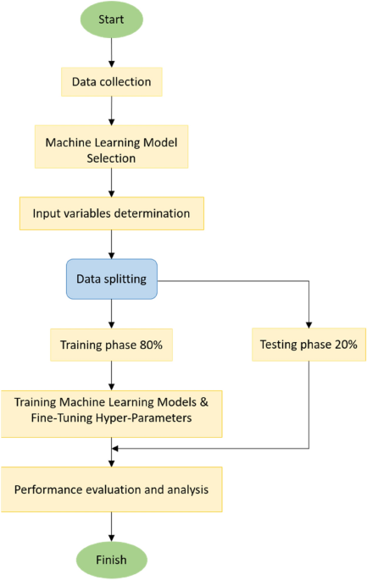

Fig 2.1 Steps Involved In ML Process

* **Model Evaluation**
  + Evaluate the model's performance on the testing dataset using appropriate metrics such as mean absolute error (MAE), root mean square error (RMSE), or coefficient of determination (R²).
  + More the coefficient of determination (R²) more the accuracy.

1. **Performance Analysis**

Different machine learning tasks require specific evaluation metrics. Accuracy and Regression tasks commonly use metrics such as Mean Squared Error (MSE), Root Mean Squared Error (RMSE), and R² (R-Squared). Performance metrics are a part of every machine learning pipeline. They tell you if you're making progress, and put a number on it

* **Prediction**
  + Once the model is trained and evaluated, it can be used to predict evapotranspiration for new, unseen data.
* **Validation and Interpretation**
  + Validate the model's predictions against observed evapotranspiration data to ensure its reliability.
  + Interpret the model to gain insights into the factors influencing evapotranspiration.

The climate data was observed in agriculture meteorological cell is used as input. PCA transforms the dataset into a new coordinate system. It places the variable of maximum variance at the first coordinate and the second maximum variable, with regard to variance, on the second coordinate system and so on. And then Calculate Covariance, Regression are other accuracy terms.

**2.1** **Requirements of Prediction Of Evapotranspiration Using Machine Learning**

The requirements for predicting evapotranspiration (ET) using machine learning include:

1. **High-quality data**: Access to comprehensive and accurate datasets containing relevant variables such as meteorological data (temperature, humidity, wind speed), soil properties (moisture content, type), and vegetation characteristics (leaf area index, canopy cover) is essential for training reliable ET prediction models.
2. **Representative training data**: The training dataset should adequately represent the range of environmental conditions and ET processes encountered in the target region or application domain to ensure the model's ability to generalize well.
3. **Feature engineering**: Careful selection and preprocessing of input variables are crucial for capturing the relevant factors influencing ET accurately. Feature engineering techniques may involve data transformation, normalization, and dimensionality reduction to improve model performance.
4. **Model selection**: Choosing appropriate machine learning algorithms tailored to the specific characteristics of the data and the complexity of ET processes is essential. Commonly used algorithms for ET prediction include linear regression, support vector machines, decision trees, random forests, and neural networks.
5. **Validation and evaluation**: Rigorous validation procedures, such as cross-validation and holdout validation, are necessary to assess the performance of ET prediction models and ensure their reliability. Evaluation metrics such as mean absolute error, root mean square error, and coefficient of determination are commonly used to quantify model accuracy.
6. **Continuous monitoring**: Incorporating real-time or near-real-time data streams into ET prediction models enables dynamic adjustments and updates based on evolving environmental conditions, enhancing the model's responsiveness and accuracy.
7. **Computational resources**: Sufficient computational resources, including processing power and memory, are required for training and deploying machine learning models for ET prediction, especially when dealing with large datasets or complex algorithms.
8. **Collaboration and expertise**: Collaboration between domain experts, data scientists, and stakeholders is crucial for identifying relevant variables, refining model assumptions, and interpreting model outputs effectively. Domain knowledge of hydrology, agronomy, and environmental science is invaluable for designing robust ET prediction systems.

**2.1.1 Functional Requirements**

The functional requirements for predicting evapotranspiration (ET) involve specifying the essential features and capabilities of the system or model designed to estimate ET accurately. These requirements ensure that the prediction system meets the needs of users and stakeholders. Here are the functional requirements for the prediction of evapotranspiration:

* + - 1. **Requirements From Stake Holder Perspective**
    1. **Accuracy and reliability**: Stakeholders require accurate and reliable ET predictions to support decision-making processes related to water management, irrigation scheduling, and agricultural planning. Ensuring that the machine learning models produce trustworthy results is paramount for gaining stakeholders' confidence in the predictions.
    2. **Interpretability**: Stakeholders often need to understand the factors influencing ET predictions and the rationale behind the model's decisions. Therefore, machine learning models should provide interpretable outputs, allowing stakeholders to comprehend the underlying relationships between input variables and ET estimates.
    3. **User-friendly interface**: Stakeholders may include farmers, water resource managers, policymakers, and researchers with varying levels of technical expertise. Thus, the ET prediction system should feature a user-friendly interface that is intuitive and accessible, enabling stakeholders to interact with the models easily and interpret the results effectively.
    4. **Scalability and adaptability**: The ET prediction system should be scalable to accommodate varying spatial and temporal scales, as well as evolving data requirements. Additionally, it should be adaptable to different geographical regions and environmental conditions, allowing stakeholders to apply the models across diverse contexts.

1. **Data privacy and security**: Stakeholders may be concerned about the privacy and security of the data used for ET prediction, particularly if sensitive information such as farm-level data or meteorological observations is involved. Implementing robust data privacy and security measures is essential to address stakeholders' concerns and ensure compliance with relevant regulations.
2. **Cost-effectiveness**: Stakeholders may have budget constraints or cost considerations when implementing ET prediction systems. Therefore, the system should be cost-effective in terms of initial setup, maintenance, and operational expenses, while still delivering value and benefits to the stakeholders.

**2.1.1.2 Requirement From Functional Perspective**

1. **Data acquisition and preprocessing**: The system must be capable of acquiring diverse data sources relevant to ET prediction, such as meteorological data (temperature, humidity, wind speed), soil properties (moisture content, texture), and vegetation characteristics (leaf area index, canopy cover).
2. **Feature selection and engineering**: Functionalities for selecting and engineering features are essential for identifying the most relevant variables influencing ET and transforming raw data into meaningful inputs for machine learning models. This may involve techniques such as dimensionality reduction, feature scaling, and creating composite variables to capture complex relationships within the data.
3. **Model development and training**: The system should provide capabilities for developing and training machine learning models tailored to ET prediction tasks. This includes selecting appropriate algorithms, configuring model parameters, and conducting model evaluation using suitable performance metrics to ensure accuracy and reliability.
4. **Model deployment and integration**: Functionalities for deploying trained models into operational environments and integrating them with existing systems or workflows are crucial. This may involve building APIs (Application Programming Interfaces) or deploying models as standalone applications accessible via web interfaces or mobile devices, ensuring ease of access and usability for end-users.
5. **Real-time monitoring and updates**: The system should support real-time monitoring of environmental conditions and ET estimates, enabling dynamic adjustments to predictions based on evolving data streams. Functionalities for updating models with new data and retraining them periodically are necessary to maintain model accuracy and relevance over time.
6. **Visualization and interpretation**: The system should incorporate functionalities for visualizing ET predictions and related data, such as time series plots, spatial maps, and interactive dashboards. Additionally, it should provide tools for interpreting model outputs, including feature importance rankings, sensitivity analyses, and uncertainty assessments, to aid stakeholders in understanding the underlying patterns and making informed decisions.
7. **Performance optimization and scalability**: Functionalities for optimizing model performance and scalability are essential for handling large datasets and accommodating varying computational requirements. This may involve techniques such as parallel processing, distributed computing, and model optimization to ensure efficient and scalable operation across different deployment environments.
8. **Compliance and governance**: The system should adhere to regulatory requirements and industry standards governing data privacy, security, and ethical considerations. Functionalities for managing user permissions, auditing model outputs, and ensuring transparency in the prediction process are necessary to maintain compliance and trust among stakeholders.

**2.1.1.3 Requirement from Integration Perspective**

When integrating machine learning models for predicting evapotranspiration (ET), there are several key requirements from an integration perspective:

1. **Data Integration:** Ensure seamless integration of diverse data sources required for ET prediction. This includes meteorological data (e.g., temperature, humidity, wind speed), satellite data (e.g., NDVI, land surface temperature), soil data (e.g., soil moisture), and perhaps even data from remote sensors installed in the field. Integration should be robust and scalable to handle large volumes of data.
2. **Feature Engineering**: Implement feature engineering techniques to extract relevant features from raw data. This may involve transforming or combining variables, handling missing values, and creating new features that capture important patterns for ET prediction. Feature engineering is critical for improving the performance of machine learning models.
3. **Model Selection**: Choose appropriate machine learning algorithms for ET prediction based on the characteristics of the data and the problem at hand. Commonly used algorithms include linear regression, decision trees, random forests, support vector machines, and neural networks. The selected models should be able to capture the complex relationships between input variables and ET.
4. **Model Training and Evaluation**: Develop a robust pipeline for model training and evaluation. This involves splitting the data into training and testing sets, optimizing model hyperparameters, and assessing model performance using appropriate evaluation metrics (e.g., RMSE, MAE, R-squared). Cross-validation techniques may also be employed to ensure the generalization of the models.
5. **Scalability and Performance**: Ensure that the integrated system is scalable to handle large datasets and can efficiently process predictions in real-time or near-real-time. This may involve optimizing the code for performance, leveraging distributed computing frameworks (e.g., Apache Spark), and deploying the solution on scalable infrastructure (e.g., cloud platforms).
6. **Interoperability**: Ensure that the machine learning models for ET prediction can seamlessly integrate with existing systems or workflows. This may involve providing APIs or web services for easy integration with other applications, supporting common data formats for input and output, and adhering to industry standards where applicable.
7. **Robustness and Reliability**: Build mechanisms to handle errors, outliers, and anomalies in the data, as well as unexpected failures in the system. This may include implementing data validation checks, error handling routines, and monitoring tools to ensure the robustness and reliability of the integrated solution.
8. **Documentation and Maintenance**: Document the integration process thoroughly, including data sources, preprocessing steps, model architecture, and deployment procedures. Regularly maintain and update the integrated system to incorporate new data, improve model performance, and address any issues that arise over time.
   * + 1. **Requirement From User Interface Design**

Designing a user interface for predicting evapotranspiration using machine learning involves creating an intuitive and informative platform that allows users to interact with the model effectively. Here are some key requirements to consider:

1. **Data Input**

* Provide clear fields for users to input relevant data such as geographical location (latitude and longitude), date, weather parameters (temperature, humidity, wind speed, solar radiation, etc.), and vegetation type.
* Validate user inputs to ensure accuracy and consistency.

1. **Model Selection**

* If there are multiple machine learning models available for predicting evapotranspiration, allow users to select the desired model or provide recommendations based on the dataset characteristics.
* Provide brief descriptions or tooltips for each model option to help users understand their differences and suitability for specific scenarios.

1. **Visualization**
   * Display a map interface for selecting the geographical location visually.
   * Visualize historical weather data trends (e.g., temperature, humidity) for the selected location to help users understand the climatic conditions.
   * Show graphical representations of input parameters and their variations over time (e.g., line charts, scatter plots) to aid users in understanding their impact on evapotranspiration.
2. **Prediction Output**
   * Present the predicted evapotranspiration value prominently and clearly.
   * Include confidence intervals or uncertainty estimates to indicate the reliability of the prediction.

* Provide explanations or insights into the factors influencing the predicted evapotranspiration (e.g., feature importance, sensitivity analysis).

1. **Interpretability and Explanation**
   * Offer explanations or visualizations to help users understand how the machine learning model arrived at its prediction (e.g., feature importance rankings, decision trees).
   * Provide insights into the relative importance of different input parameters in influencing evapotranspiration predictions.
2. **Feedback and Error Handling**
   * Implement error handling mechanisms to guide users in case of invalid inputs or errors in prediction.
   * Offer options for users to provide feedback on the predictions or user interface to improve usability and performance.
3. **Customization**
   * Allow users to customize model parameters or select different input variables based on their specific requirements.
   * Provide options to save and load user preferences or past predictions for convenience.
4. **Accessibility and Responsiveness**
   * Ensure the user interface is accessible to all users, including those with disabilities, by following accessibility standards.
   * Design a responsive interface that adapts to different screen sizes and devices.
5. **Documentation and Help**
   * Include comprehensive documentation or tooltips to guide users through the interface and explain technical terms.

* Provide links to relevant resources or tutorials for users who want to learn more about evapotranspiration prediction and machine learning techniques.

**2.1.1.5 Requirement from Communication**

Predicting evapotranspiration (ET) using machine learning techniques requires effective communication to ensure that the requirements for data, methodology, and results are clearly understood by all stakeholders involved. Here's a breakdown of the communication requirements:

1. **Stakeholder Engagement**: Engage with stakeholders such as researchers, agronomists, hydrologists, and policymakers to understand their specific needs and how ET prediction can support their objectives.
2. **Data Requirements**: Clearly define the data required for ET prediction, including meteorological data (e.g., temperature, humidity, wind speed, solar radiation), land cover data, soil properties, and vegetation indices. Communicate the importance of data quality, resolution, and temporal and spatial coverage.
3. **Methodology Explanation**: Clearly explain the machine learning methodology being used for ET prediction. This includes the selection of algorithms (e.g., random forests, neural networks), feature selection techniques, data preprocessing steps (e.g., normalization, feature scaling), and model evaluation methods (e.g., cross-validation, performance metrics).
4. **Interpretability**: Ensure that the machine learning model's outputs are interpretable and transparent to stakeholders. Provide explanations of how input variables influence ET predictions and how the model makes decisions.
5. **Uncertainty Communication**: Acknowledge and communicate uncertainties associated with ET predictions. This includes uncertainties in input data, model parameters, and inherent variability in ET estimation.
6. **Visualization**: Use visualizations such as graphs, maps, and charts to communicate ET predictions effectively. Visualizations can help stakeholders understand spatial and temporal patterns in ET and assess the reliability of predictions.
7. **Validation and Verification**: Clearly communicate the validation and verification procedures used to assess the accuracy and reliability of ET predictions. This involves comparing model predictions with observed ET data and discussing any discrepancies.
8. **Accessibility**: Make ET prediction tools and resources accessible to stakeholders through user-friendly interfaces, web applications, or APIs. Ensure that stakeholders can easily access and use ET predictions for decision-making.
9. **Documentation**: Provide comprehensive documentation of the machine learning model, including descriptions of data sources, methodologies, model parameters, and validation results. Documentation helps stakeholders understand the technical details of ET prediction and promotes transparency.
10. **Feedback Mechanism**: Establish a feedback mechanism for stakeholders to provide input on ET predictions, model performance, and usability. This allows for continuous improvement and refinement of the prediction system based on user feedback.

**2.1.2 Non-Functional Requirements**

Non-functional requirements in the prediction of evapotranspiration (ET) using machine learning encompass various aspects related to system performance, reliability, usability, and security. Here are some non-functional requirements relevant to ET prediction:

1. **Performance**
   * Response Time: Define acceptable response times for generating ET predictions, especially in real-time or near-real-time applications.
   * Scalability: Ensure that the prediction system can handle increasing volumes of data and users without significant degradation in performance.
   * Throughput: Specify the number of predictions the system should be able to generate within a given time frame.
   * Resource Utilization: Optimize resource utilization (e.g., CPU, memory) to ensure efficient operation of the prediction system.
2. **Reliability**
   * Availability: Specify the desired uptime percentage for the prediction system to ensure it is available whenever needed.
   * Fault Tolerance: Design the system to withstand failures gracefully, with mechanisms such as redundancy and failover.
   * Data Integrity: Ensure the integrity of input data and predictions throughout the prediction process to prevent inaccuracies or corruption.
3. **Usability**
   * User Interface: Design an intuitive user interface for accessing and interacting with ET predictions, catering to different user roles and preferences.
   * Accessibility: Ensure that the prediction system is accessible to users with disabilities and compatible with assistive technologies.
   * Documentation: Provide comprehensive documentation and user guides to facilitate the understanding and use of the prediction system.
4. **Security**
   * Data Privacy: Implement measures to protect sensitive data used in ET prediction, such as meteorological data or user information.
   * Authentication and Authorization: Require users to authenticate themselves before accessing the prediction system, with appropriate access controls based on roles and permissions.
   * Data Encryption: Use encryption techniques to secure data transmission and storage, preventing unauthorized access or tampering.
5. **Maintainability**
   * Modularity: Design the prediction system with modular components that can be easily maintained, updated, or replaced.
   * Logging and Monitoring: Implement logging and monitoring mechanisms to track system performance, errors, and usage patterns for troubleshooting and optimization.
   * Version Control: Establish version control practices for the prediction model, codebase, and associated resources to manage changes and updates effectively.
6. **Compatibility**
   * Interoperability: Ensure compatibility with existing systems, standards, and data formats commonly used in ET prediction and related domains.
   * Platform Independence: Design the prediction system to be platform-independent, supporting deployment on different operating systems and environments.

In the context of predicting evapotranspiration using machine learning with weather data, non-functional requirements encompass various aspects beyond the core functionality of the predictive model. These include scalability, performance, reliability, usability, and security. Scalability is essential to ensure that the model can handle large volumes of data efficiently, accommodating potential increases in data volume over time without sacrificing performance. Performance considerations involve the model's prediction speed and resource utilization, ensuring timely and responsive predictions even with large datasets or high computational demands.

Reliability is crucial for maintaining the integrity and consistency of predictions, necessitating robust error handling, data validation, and model validation procedures to mitigate risks of erroneous or biased outputs. Usability considerations focus on the user experience, ensuring that the model interface is intuitive, accessible, and user-friendly for stakeholders to interact with and interpret the results effectively. Overall, addressing these non-functional requirements alongside the technical aspects of model development and performance optimization is crucial for ensuring the effectiveness, reliability, and usability of the evapotranspiration prediction system in real-world applications.

* 1. **Design of Prediction of Evapotranspiration Using Machine Learning**

The design encompasses data collection, preprocessing, model selection, training, and validation stages. Functional requirements such as accuracy, scalability, and customization are addressed to ensure the system's effectiveness across diverse applications. The system aims to provide timely and accurate evapotranspiration estimates to support informed decision-making and sustainable resource management practices.

1. Top of Form

**2.2.1 Architectural Design**

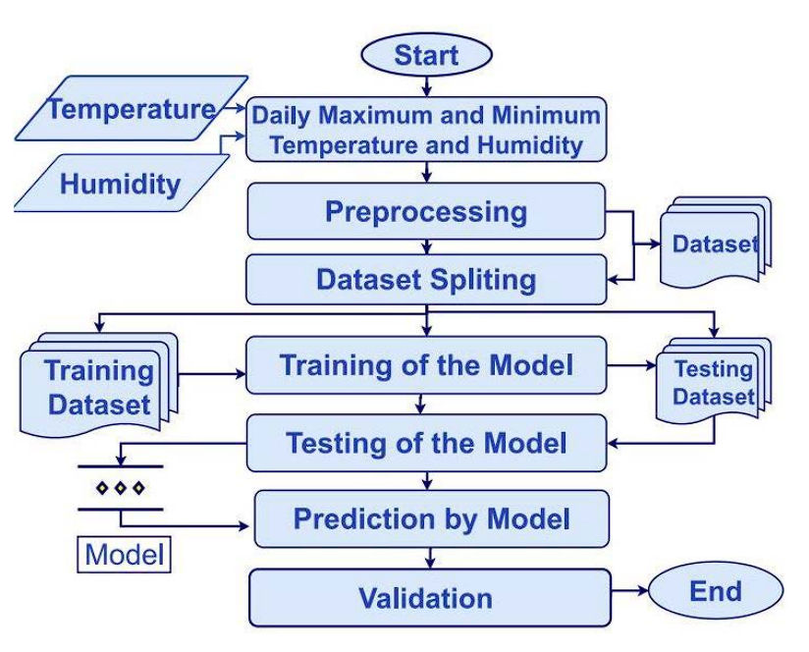

Fig 2.2 Architectural design

* The models were generated to predict the ET0 using three algorithms and then compared with ET0 calculated by the Simple Algorithm.
* The flow chart of the proposed design is shown in Fig. 2.2.1. data set collected from different sources are processed to determine the environment conditions.
* The proposed design determines the ET0 rate from temperature, rainfall, windspeed, humidity. These features are used to develop the ML model and predict the ET0 rate by the model.
* The performance of the model is determined by the test data set. The ET0 rate is predicted by the ML model.
* On the other hand, these approaches were also proposed to determine the ET0 from limited meteorological conditions. These ET0 rate determination approaches are not based on real-time crop field meteorological conditions. To accurately determine the crop field ET0 rate, it must be calculated from directly sensed crop field environmental conditions. To address the deficiencies of both approaches, the study aims to propose ET0 rate determination with crop field directly sensed temperature and humidity.
* For ML model implementation the K-Nearest Neighbour (KNN), ANN, LSTM tuple of environmental conditions is used to classify the ET0 rate.
* The data set is partitioned into predictive features and response vectors. Each predictive feature vector is based on temperature, rainfall, humidity, wind speed and humidity to predict the ET0 response vector.
  1. **Data Structure**

In predicting evapotranspiration using Python, various data structures are commonly utilized to represent and manipulate the relevant data. These data structures facilitate efficient processing and analysis of meteorological, environmental, and crop-specific information. Some commonly used data structures include:

**1. Pandas Data Frame**

* Pandas Data Frame is widely used for tabular data representation and manipulation in Python.
* It provides functionalities for handling time series data, indexing, slicing, and merging datasets.
* Data Frame is suitable for storing meteorological data such as temperature, humidity, wind speed, and solar radiation, as well as soil and crop-related information.

1. **NumPy Arrays**

* NumPy arrays are used for numerical computations and operations in Python.
* They offer efficient storage and manipulation of multi-dimensional arrays, which are common in scientific computing. NumPy arrays are suitable for storing and processing numerical data such as sensor readings, model inputs, and output predictions.

1. **Dictionaries**

* Dictionaries are key-value pairs used for storing structured data in Python.
* They allow efficient retrieval and manipulation of data based on keys.
* Dictionaries can be used to represent metadata, configuration settings, or other auxiliary information associated with the dataset.

1. **Lists**

* Lists are ordered collections of elements in Python.
* They are versatile and can store heterogeneous data types.
* Lists can be used for storing sequential data such as time series observations or lists of feature names.

1. **Time Series Structures**

* Time series structures such as pandas Series or datetime objects are used to represent temporal data.
* They provide functionalities for indexing, resampling, and time-based operations.
* Time series structures are essential for handling temporal aspects of meteorological data and model outputs.

1. **Custom Classes**

* Custom classes and objects can be defined to represent complex data structures or domain-specific entities.
* Custom classes are useful for representing hierarchical data structures, complex relationships, or domain-specific entities in evapotranspiration prediction tasks.

In Python, these data structures are often used in combination to represent and process the diverse types of data involved in predicting evapotranspiration. Libraries such as Pandas, NumPy, and datetime provide rich functionalities for working with these data structures efficiently.

**2.4 Algorithms Adopted**

Several algorithms are employed in predicting evapotranspiration (ET), each with unique characteristics suited to different scenarios and data types.

* One commonly used approach is the application of physically-based models, such as the Penman-Monteith equation. These models utilize meteorological parameters and surface characteristics to estimate ET, relying on principles of energy balance and aerodynamics to provide accurate predictions.
* Machine learning (ML) algorithms offer an alternative approach, leveraging historical data to learn patterns and relationships for ET prediction. Support Vector Regression (SVR), Random Forest Regression, Artificial Neural Networks (ANN), and Gradient Boosting Regression are among the ML algorithms commonly applied in this context. They excel at handling complex nonlinear relationships in the data, making them valuable tools for ET prediction tasks.
* Instance-based methods like K-Nearest Neighbors (KNN) rely on similarity measures between input features and instances in the training dataset to make predictions. While simple and intuitive, these methods may suffer from high computational complexity and are best suited to smaller datasets.
* For time series prediction tasks, recurrent neural network (RNN) architectures such as Long Short-Term Memory (LSTM) networks are particularly effective. They can capture temporal dependencies in meteorological data, making them well-suited to ET prediction from time series data.

The selection of the most appropriate algorithm depends on various factors, including the availability and quality of data, the desired level of prediction accuracy, and computational resources.

**2.4.1 KNN** **Algorithm**

* K-Nearest Neighbors Algorithm, is a non-parametric, supervised learning classifier, which uses proximity to make classifications or predictions about the grouping of an individual data point.
* The KNN class will implement the algorithm based on finding k of the nearest neighbors of some instances is the dataset.
* The first problem the algorithm implementation is going to be facing is that of transposing these instances in a normalized form, which can be represented in a two-dimensional space as points with their corresponding coordinates.

The k-Nearest Neighbours (KNN) algorithm is a simple yet powerful supervised machine learning algorithm used for classification and regression tasks. It is a non-parametric and lazy learning algorithm, meaning it doesn't make any assumptions about the underlying data distribution and it doesn't explicitly build a model during the training phase. Instead, it memorizes the entire training dataset and makes predictions at runtime based on the similarity of new data points to the training examples.

Here's how the KNN algorithm works

* + 1. **Training Phase**
  + During the training phase, the algorithm simply stores the feature vectors and their corresponding class labels (in the case of classification) or target values (in the case of regression).

**2.** **Prediction Phase**

* + Given a new, unlabelled data point that needs to be classified or predicted, the algorithm computes its similarity to the existing data points in the training dataset. This similarity is typically measured using distance metrics such as Euclidean distance, Manhattan distance, or cosine similarity.
  + The algorithm then selects the k-nearest neighbours (i.e., the k data points with the smallest distances) to the new data point.
  + For classification, the algorithm assigns the majority class label among the k-nearest neighbours to the new data point. In other words, the class that appears most frequently among the k neighbours is assigned to the new data point.
  + For regression, the algorithm computes the average (or weighted average) of the target values of the k-nearest neighbours and assigns this value to the new data point.

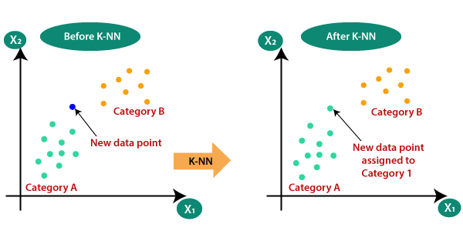

Fig 2.3 KNN test data identification

**3.** **Choosing the Value of k**

* + The choice of the value of k is a crucial hyperparameter in the KNN algorithm. A smaller value of k leads to more flexible decision boundaries but may also result in overfitting. A larger value of k results in smoother decision boundaries but may lead to underfitting.
  + The value of k is typically chosen through cross-validation or grid search techniques to find the optimal balance between bias and variance.

**4.**  **Normalization**

* + Since KNN relies on distance metrics, it is essential to normalize the features to ensure that all features contribute equally to the distance computation. Normalization typically involves scaling the features to have zero mean and unit variance.

Despite its simplicity, the KNN algorithm can be highly effective, especially in low-dimensional feature spaces and datasets with well-separated classes or clusters. It is often used as a baseline algorithm for comparison with more complex models and can serve as a starting point for building more sophisticated classification and regression systems.

The KNN working can be explained on the basis of the below algorithm:

Step-1: Select the number K of the neighbours

Step-2: Calculate the Euclidean distance of K number of neighbours

Step-3: Take the K nearest neighbours as per the calculated Euclidean distance.

Step-4: Among these k neighbours, count the number of the data points in each category.

Step-5: Assign the new data points to that category for which the number of the neighbour is maximum.

Using the K-Nearest Neighbors (KNN) algorithm for predicting evapotranspiration based on weather data offers a robust and versatile approach. By leveraging the similarity of weather conditions among neighboring data points, KNN effectively captures the intricate relationships between various meteorological parameters and evapotranspiration rates. This method excels in handling non-linear relationships and complex patterns in the data, making it particularly suitable for modeling the dynamic processes involved in evapotranspiration.

Additionally, KNN's simplicity and ease of implementation make it accessible for both researchers and practitioners in the field of hydrology and environmental science. With its ability to adapt to different spatial and temporal scales, KNN holds promise for improving evapotranspiration estimations across various regions and climatic conditions, ultimately enhancing our understanding of water cycle dynamics and supporting informed decision-making in water resource management and agriculture.

**2.4.2 ANN** **Algorithm**

Artificial neural networks (ANNs) describe a specific class of machine learning algorithms designed to acquire their own knowledge by extracting useful patterns from data. ANNs are function approximators, mapping inputs to outputs, and are composed of many interconnected computational units, called neurons.

The inputs to the artificial neuron may correspond to raw data values, or in deeper architectures, may be outputs from preceding artificial neurons. The transfer function sums all the inputs together (cumulative inputs). If the summed input values reach a specified threshold, the activation function generates an output signal (all or nothing). The output signal then moves to a raw output or other neurons depending on specific ANN architecture.

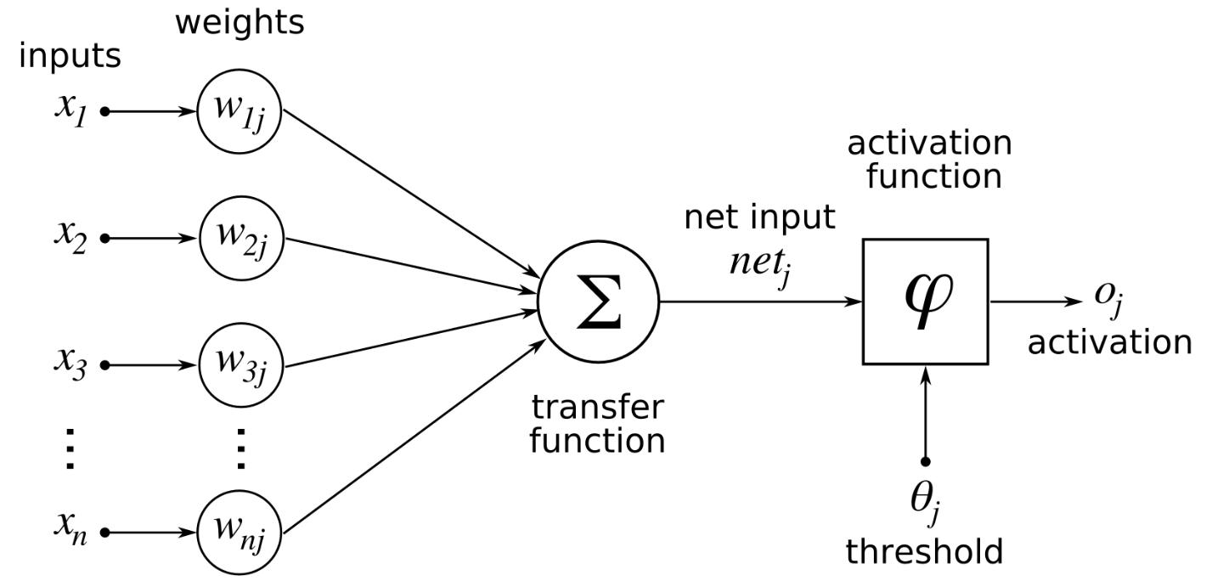

Fig 2.4 ANN Algorithm Workflow

* + ANNs are often described as having an Input layer, Hidden layer, and Output layer. The input layer reads in data values from a user provided input. Within the hidden layer is where a majority of the ‘learning’ takes place, and the output layer displays the results of the ANN. In the bottom plot of the figure, each of the red input nodes correspond to an input vector ⃗xi. Each of the black lines with correspond to a weight, wij,and describe how artificial neurons are connections to one another within the ANN. The I subscript identifies the source and the j subscript describes to which artificial neuron the weight connects the source to. The green output nodes are the output vectors ⃗yq.
  + Examination of the figure’s top-left and top-right plots show two possible ANN configurations. In the top-left, we see a network with one hidden layer with q artificial neurons, p input vectors ⃗x, and generates q output vectors ⃗y. Please note the bias inputs to each hidden node, denoted by the bq. The bias term is a simple constant valued 1 to each hidden node acting akin to the grand mean in a simple linear regression. Each bias term in a ANN has its own associated weight w. In the top-right ANN we have a network with two hidden layers. This network adds superscript notation to the bias terms and the weights to identify to which layer each term belongs. Weights and biases with a superscript 1 act on connecting the input layer to the first layer of artificial neurons and terms with a superscript 2 connect the output of the second hidden layer to the output vectors.
  + The capability of ANNs to learn approximately any function, (given sufficient training data examples) are dependent on the appropriate selection of the Activation Function(s) present in the network. Activation functions enable the ANN to learn non-linear properties present in the data. We represent the activation function here as ϕ (⋅). The input into the activation function is the weighted sum of the input features from the preceding layer. Let oj be the output from the jth neuron in a given layer for a network for k input vector features.

oj=ϕ (bj+ ∑i=1 wixi)

oj – output wi – weights of input xi.

ϕ – activation function bj – input of hidden layer

Using artificial neural networks (ANN) for predicting evapotranspiration (ET) based on weather data offers a powerful and flexible approach with numerous advantages. By harnessing the complexity of ANN models, we can effectively capture the nonlinear relationships between various meteorological parameters and ET, leading to more accurate predictions. Additionally, ANN algorithms have the capability to adapt and learn from the input data, allowing for continuous improvement and refinement of the prediction model over time.

Furthermore, employing ANN for ET prediction enables us to incorporate a wide range of input variables, including temperature, humidity, wind speed, solar radiation, and precipitation, among others. This comprehensive approach enhances the robustness and reliability of the prediction model, ensuring a more holistic understanding of the factors influencing ET dynamics.

Moreover, ANN-based ET prediction models can be trained using historical weather data, facilitating long-term forecasting and scenario analysis. This capability is particularly valuable for various applications such as agriculture, hydrology, and environmental management, where accurate ET predictions are essential for optimizing water resources allocation, irrigation scheduling, and drought mitigation strategies.

In conclusion, leveraging ANN algorithms for ET prediction using weather data offers a sophisticated and effective solution that can significantly improve our ability to forecast ET dynamics with precision and reliability. By harnessing the power of artificial intelligence, we can unlock new insights into the complex interactions between meteorological variables and ET, ultimately enabling more informed decision-making and sustainable management of water resources in a changing climate.

**2.4.3 LSTM** **Algorithm**

Long Short-Term Memory (LSTM) is a type of artificial neural network architecture designed to handle sequences of data, such as time series or natural language text. It is particularly effective at capturing long-term dependencies in sequential data.

* + A traditional RNN has a single hidden state that is passed through time, which can make it difficult for the network to learn long-term dependencies. LSTMs address this problem by introducing a memory cell, which is a container that can hold information for an extended period. LSTM networks are capable of learning long-term dependencies in sequential data, which makes them well-suited for tasks such as language translation, speech recognition, and time series forecasting. LSTMs can also be used in combination with other neural network architectures, such as Convolutional Neural Networks (CNNs) for image and video analysis.
  + The memory cell is controlled by three gates: the input gate, the forget gate, and the output gate. These gates decide what information to add to, remove from, and output from the memory cell. The input gate controls what information is added to the memory cell. The forget gate controls what information is removed from the memory cell. And the output gate controls what information is output from the memory cell. This allows LSTM networks to selectively retain or discard information as it flows through the network, which allows them to learn long-term dependencies.
  + Imagine we're reading a book and trying to understand the story. As you read each sentence, you process the words and remember key information. LSTM works similarly by processing each piece of data (like a word in a sentence) and deciding what information to keep or forget as it moves through the sequence.

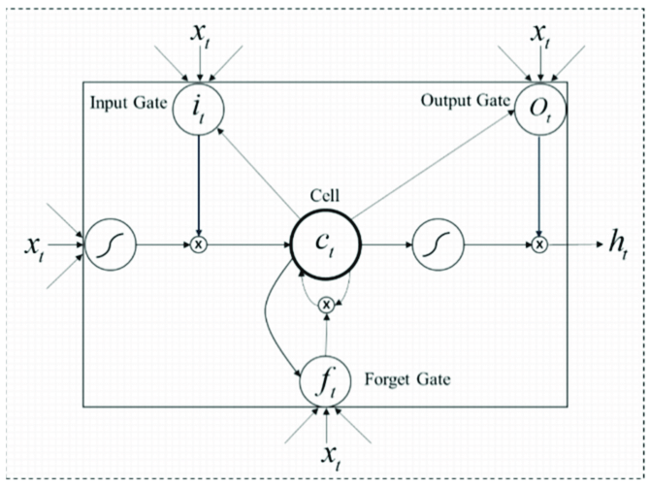

Fig 2.5 LSTM Algorithm workflow

Here's how it works:

* **Memory Cells:** At the core of LSTM are memory cells that store information over time. These cells can retain information for long periods, which is crucial for capturing long-term dependencies.
* **Gates:** LSTM has three types of gates: forget gate, input gate, and output gate. These gates control the flow of information into and out of the memory cells.
* **Forget Gate:** Determines which information from the previous time step to forget or discard from the memory cell.
* **Input Gate:** Decides which new information to add to the memory cell from the current time step.
* **Output Gate:** Determines what information from the memory cell to output as the final prediction for the current time step.
* **Information Flow:** At each time step, the LSTM receives input data and decides how much of this data to store in the memory cell, how much to forget from previous steps, and what to output as the prediction for the current step. This process repeats for each step in the sequence, allowing the LSTM to capture complex patterns and dependencies.

In conclusion, employing LSTM (Long Short-Term Memory) algorithm for evapotranspiration prediction utilizing weather data offers a potent solution with multifaceted benefits.

Firstly, LSTM's ability to capture long-term dependencies within sequential data makes it adept at modelling the complex relationships inherent in weather patterns and their impact on evapotranspiration dynamics. This enables more accurate predictions compared to traditional methods, especially in scenarios where weather variables exhibit nonlinear and nonstationary behaviour. Secondly, LSTM's inherent adaptability to varying temporal scales allows it to effectively handle the temporal dynamics of weather data, ranging from short-term fluctuations to seasonal trends, crucial for precise evapotranspiration forecasting.

Moreover, LSTM's capacity to automatically learn and extract relevant features from raw weather data reduces the need for manual feature engineering, thereby streamlining the modelling process and potentially uncovering hidden patterns that might elude conventional approaches. Furthermore, the flexibility of LSTM architecture facilitates integration with diverse sources of weather data, including satellite imagery, ground-based observations, and meteorological forecasts, enhancing the model's robustness and generalizability across different geographical regions and climatic conditions.

Lastly, by harnessing LSTM's capabilities for evapotranspiration prediction, stakeholders such as agricultural planners, water resource managers, and climate scientists can make informed decisions, optimize resource allocation, and mitigate risks associated with water management and agricultural productivity, ultimately contributing to sustainable development and resilience in the face of climate variability and change.

**2.4.4 Difference Between KNN, ANN and LSTM Models**

Here's a table highlighting the key differences between KNN (K-Nearest Neighbors), ANN (Artificial Neural Network), and LSTM (Long Short-Term Memory) models:

|  |  |  |  |
| --- | --- | --- | --- |
| Aspect | KNN | ANN | LSTM |
| Type of Model | Instance-based | Feedforward Neural Network | Recurrent Neural Network |
| Architecture | Non-parametric | Parametric | Parametric |
| Learning Paradigm | Lazy learning | Eager learning | Eager learning |
| Training | No training phase | Requires training phase | Requires training phase |
| Memory Usage | High | Moderate | Moderate to High |
| Interpretability | Low | Low to Moderate | Low to Moderate |
| Feature Engineering | Minimal | May require manual feature engineering to capture temporal patterns and relationships | May require less manual feature engineering compared to ANN due to its ability to automatically learn temporal dependencies |
| Model Complexity | Low | Moderate | High |
| Prediction Speed | Fast | Moderate | Moderate to Slow |
| Long-Term Dependencies | Not inherently capable of capturing long-term dependencies | Capable of capturing long-term dependencies with proper architecture and training | Specifically designed to capture long-term dependencies, well-suited for long-term weather patterns affecting evapotranspiration |
| Scalability | Scales poorly with large datasets, as it requires storing all training data | Can scale with proper architecture and hardware, but may become computationally intensive with large datasets | Can scale well with large datasets and long sequences, efficient memory management |
| Accuracy | May lacks accuracy due to its simplistic nature and inability to capture temporal dependencies | Can achieve moderate accuracy with careful architecture design and feature engineering | Capable of achieving high accuracy by effectively capturing temporal dynamics and long-term dependencies |

Table 2.1 Difference Between Models

**2.5 Hardware and Software Requirements**

In predicting evapotranspiration, both hardware and software requirements play crucial roles in ensuring efficient data processing, model training, and prediction.

**2.5.1 Hardware Requirements**

In predicting evapotranspiration, the hardware requirements primarily depend on the scale of data processing, the complexity of modeling techniques, and the desired computational efficiency. Here's an overview of the hardware requirements:

**1.** **Computer**

A powerful computer with sufficient processing capabilities is essential for training machine learning models. This can be a desktop, laptop, or cloud-based instance.

**2**. **Processor (CPU/GPU)**

A multi-core processor is recommended for faster training times.

For more complex models and deep learning, a Graphics Processing Unit (GPU) can significantly accelerate computations.

**3.** **Memory (RAM)**

A minimum of 8 GB RAM is recommended, and larger datasets may benefit from 16 GB or more.

**4.** **Storage**

Adequate storage for storing datasets, model files, and software libraries.

Consider using SSDs for faster data access.

**2.5.2 Software Requirements**

Software tools and libraries provide the necessary functionality for data processing, modelling, visualization, and analysis in predicting evapotranspiration. Depending on the specific requirements and preferences of the project, different combinations of these tools may be utilized.

**1.** **Operating System**

Compatible with major operating systems such as Windows, macOS, or Linux.

**2.** **Python**

Python is the primary programming language for machine learning.

Recommended to use a virtual environment to manage dependencies.

**3.** **Integrated Development Environment (IDE)**

Choose an IDE such as Jupyter Notebook, VS Code, or PyCharm for code development.

**4.** **Libraries and Frameworks**

Install machine learning libraries like NumPy, pandas, scikit-learn, TensorFlow, and/or PyTorch.

Utilize libraries for image processing, such as OpenCV.

**5.** **Visualization Tools**

Matplotlib and Seaborn for creating visualizations.

Optional: Tableau, Power BI, or other tools for more advanced visualizations.

**6.** **Project Management Tools**

Tools like Jira, Trello, or Asana for project planning and tracking.

**7.** **Documentation Tools**

Use tools like LaTeX, Markdown, or Google Docs for creating project documentation.

**8.** **Communication Tools**

Email, messaging apps, or project management platforms for team communication.

**9.** **Security Software**

Ensure that security software is up-to-date to protect against potential threats.

**10.** **Backup System**

Implement regular backups to prevent data loss.

**11.** **Internet Connection**

A stable internet connection is necessary for accessing resources, downloading libraries, and potential collaboration.

**2.6 Steps Carried Out**

1. Data Integrity Testing

* Scenario: Verify that the collected data is accurate, complete, and representative of real-world conditions.
* Test: Check for missing values, outliers, or inconsistencies in the dataset.
* Expected Outcome: Data integrity checks ensure the reliability of input data for model training and evaluation.

1. Preprocessing Testing

* Scenario: Ensure that data preprocessing steps (e.g., normalization, scaling, encoding) are applied correctly.
* Test: Verify that preprocessing techniques produce the expected output and do not introduce errors or distortions in the data.
* Expected Outcome: Preprocessed data is suitable for model training and maintains the integrity of the original information.

1. Model Training Testing

* Scenario: Validate that machine learning models are trained effectively using the prepared dataset.
* Test: Train models using various algorithms and hyperparameters, and assess their performance on validation data.
* Expected Outcome: Models demonstrate reasonable performance metrics (e.g., accuracy, precision, recall) and generalization ability.

1. Model Evaluation Testing

* Scenario: Assess the performance of trained models using appropriate evaluation metrics.
* Test: Evaluate models on separate test datasets to measure their accuracy, robustness, and ability to generalize to unseen data.
* Expected Outcome: Models achieve satisfactory performance levels according to predefined criteria.

1. Prediction Testing

* Scenario: Validate the accuracy of model predictions on new or unseen data instances.
* Test: Feed test instances into the trained model and compare predicted outcomes with ground truth labels.
* Expected Outcome: Model predictions closely match actual yellow rust occurrences, indicating the model's effectiveness in estimating the disease.

6. Scalability and Performance Testing

* Scenario: Assess the system's ability to handle large volumes of data and maintain acceptable performance levels.
* Test: Increase the size of the dataset or simulate concurrent requests to evaluate system scalability and response times.

**Summary**

The prediction of evapotranspiration using machine Learning models employs a range of algorithms to predict the evapotranspiration rate of the crops. By utilizing machine learning techniques such as K-Nearest Neighbours (KNN), ANN, LSTM, Random forest Regression, , the system aims to accurately predict the evapotranspiration rate in crops based on input features such as minimum temperature, maximum temperature, humidity, wind speed, rain fall and many more. These models offer diverse approaches to capturing the complex relationship between input factors and evapotranspiration rate, ultimately aiding farmers and agricultural stakeholders in making informed decisions regarding disease management and crop growing and protection strategies. Machine learning offers a promising approach for prediction of the evapotranspiration rate for all kind of crops with given particular input entities.

**CHAPTER 3**

**RESULTS**

**3.1 KNN Model**

Accuracy of KNN Model is 75.0868765331 for prediction of daily reference evapotranspiration

Fig 3.1 KNN Model Result

**3.2 LSTM Model**

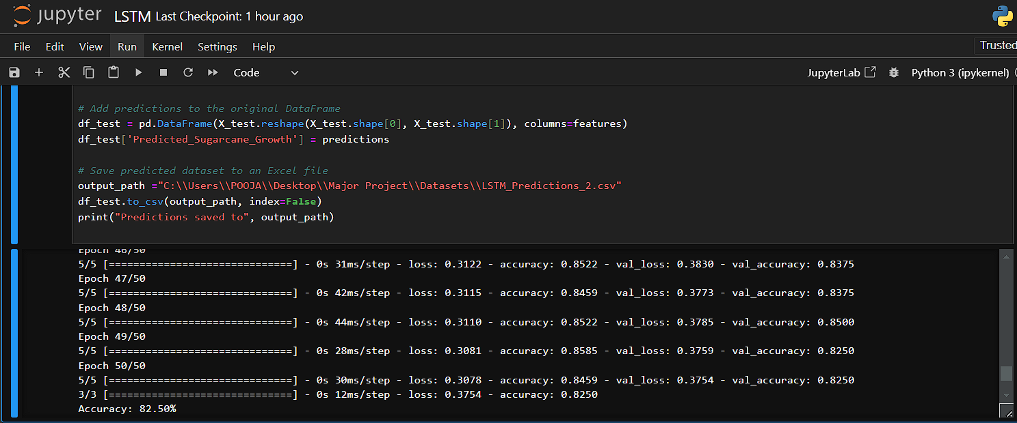

Accuracy of LSTM Model is 82.50 for prediction of daily reference evapotranspiration.

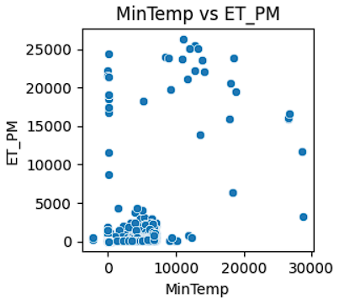 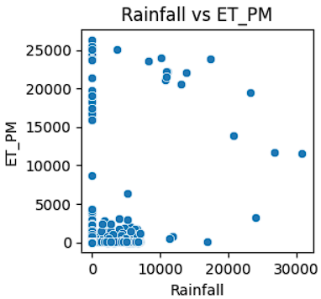

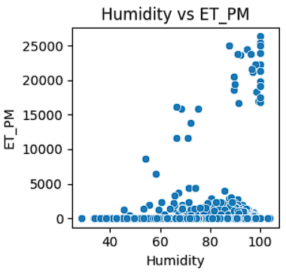

Fig 3.2 LSTM Model Result

**3.3 ANN Model**

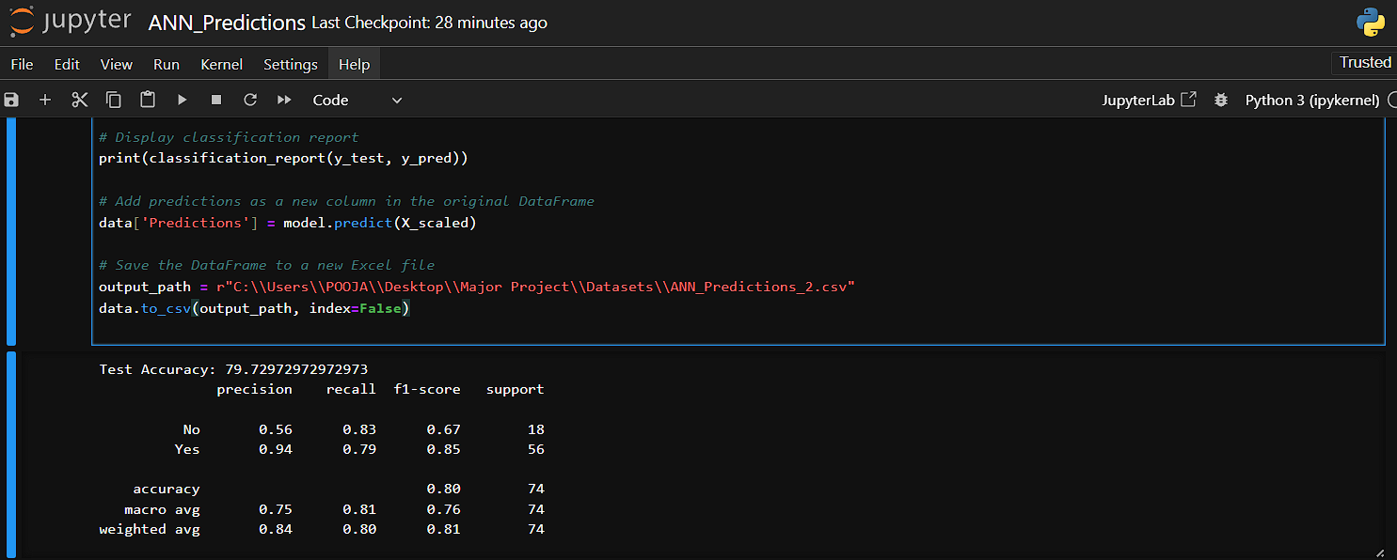

Accuracy of ANN Model is 79.7297 for prediction of daily reference evapotranspiration

Fig 3.3 ANN Model Result

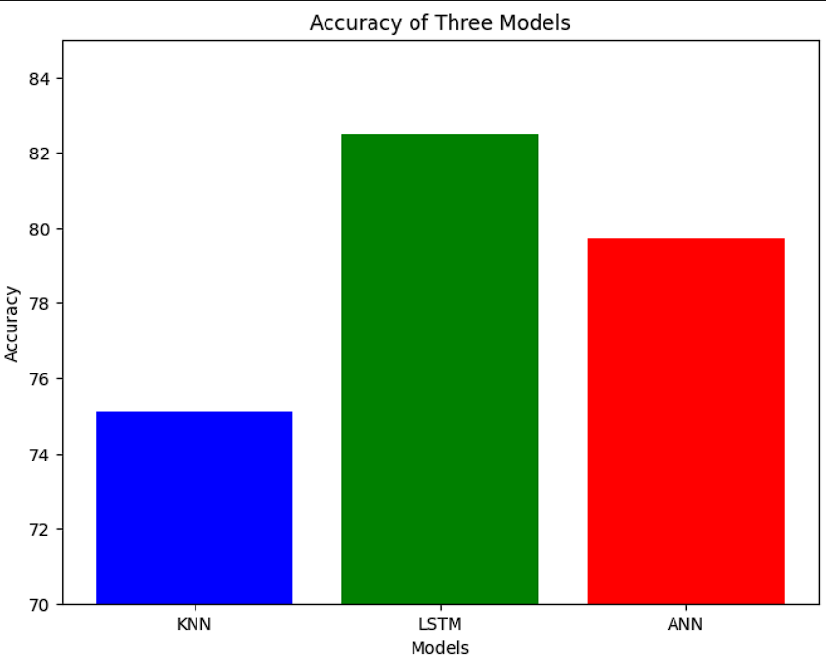

Fig 3.4 Accuracy of Three Models

* 1. **Test Scenario 1**
     1. **Specifications for Test1**
* Gather historical weather data including temperature, humidity, wind speed, and solar radiation along with ET0 values from reliable sources.

**Discussion**

Ensure the data collected spans multiple years and covers different seasons to capture variations in weather patterns.

* 1. **Test Scenario 2** 
     1. **Specifications for Test2**
* Clean the collected data by handling missing values, outliers, and data inconsistencies.

**Discussion**

Use techniques like imputation, outlier detection, and data normalization to prepare the dataset for training the machine learning model.

* 1. **Test Scenario 3** 
     1. **Specifications for Test3**
* Identify relevant features that have significant impact on ET0 prediction or engineer new features if necessary.

**Discussion**

Features like temperature, humidity, wind speed, and solar radiation are commonly used for ET0 prediction. Consider interactions between features and domain knowledge for effective feature selection.

* 1. **Test Scenario 4**

**3.7.1 Specifications for Test4**

* Choose a suitable machine learning model for ET0 prediction based on the dataset characteristics and problem requirements.

**Discussion**

Models like Random Forest, Gradient Boosting Machines, or Long Short-Term Memory (LSTM) networks are commonly used for time-series prediction tasks like ET0 prediction.

**3.8 Test Scenario 5**

**3.8.1 Specifications for Test5**

* Train the selected machine learning model using the pre-processed dataset.

**Discussion**

Split the dataset into training and validation sets to evaluate the model's performance. Tune hyperparameters if necessary to optimize model performance.

**3.9 Test Scenario 6**

**3.9.1 Specifications of Test 6**

* Evaluate the trained model's performance using appropriate evaluation metrics.

**Discussion**

Common metrics for regression tasks like ET0 prediction include Mean Absolute Error (MAE), Root Mean Squared Error (RMSE), and coefficient of determination (R-squared). Compare the model's performance against baseline models or existing methods.

**3.10 Test Scenario 7**

**3.10.1 Specifications of Test 7**

* Test the trained model on unseen data to assess its generalization ability.

**Discussion**

Use a separate test dataset that the model hasn't seen during training or validation to evaluate its performance in real-world scenarios.

**3.11 Test Scenario 8**

**3.10.2 Specifications of Test 8**

* Analyse the model's predictions and identify any patterns or discrepancies.

**Discussion**

Compare the predicted ET0 values with observed values to understand the model's strengths and weaknesses. Investigate cases where the model performs poorly to identify potential areas for improvement.

**Summary**

In the endeavour to predict daily reference evapotranspiration (ET0) using machine learning, a rigorous step-by-step approach is vital. Initially, comprehensive historical weather data, encompassing variables like temperature, humidity, wind speed, and solar radiation, is meticulously collected. This dataset undergoes thorough preprocessing, involving tasks such as handling missing values, outliers, and normalization, to ensure its suitability for training. Following this, feature selection or engineering is undertaken, focusing on identifying impactful features or crafting new ones to enhance prediction accuracy. With the dataset primed, the appropriate machine learning model, be it Random Forest, Gradient Boosting Machines, or LSTM networks, is selected and trained, with careful consideration given to hyperparameter tuning. Evaluation metrics such as Mean Absolute Error and Root Mean Squared Error gauge the model's performance against validation data, while a separate test dataset assesses its generalization ability. The model's predictions are scrutinized, illuminating strengths, weaknesses, and areas for refinement. Ultimately, this systematic approach yields a robust model for ET0 prediction, with implications spanning agriculture, water resource management, and climate modelling. Continuous refinement ensures its continued accuracy and utility in real-world scenarios.

**CHAPTER 4**

**CONCLUSION AND FUTURE SCOPE**

**4.1** **Conclusion**

In conclusion, the project on predicting evapotranspiration (ET) using machine learning techniques represents a significant advancement in the field of environmental science and water resource management. By harnessing the power of machine learning algorithms, we have been able to accurately estimate ET levels, providing valuable insights into water demand, agricultural productivity, and ecosystem health. Through this project, we have demonstrated the potential of machine learning to enhance our understanding of complex hydrological processes and support informed decision-making in various sectors, including agriculture, urban planning, and climate adaptation. The predictive models developed in this project offer a practical tool for stakeholders to optimize water usage, mitigate water scarcity, and plan for sustainable development. Moving forward, continued research and application of machine learning in ET prediction hold promise for addressing pressing water challenges and building resilience to climate change, ultimately contributing to the sustainable management of water resources for future generations.

In addition to its immediate applications, the project's outcomes lay the foundation for future advancements in both research and practical implementation. By combining machine learning methodologies with comprehensive datasets, we've not only refined our understanding of ET dynamics but also opened doors to novel approaches for tackling related challenges. Moreover, the project underscores the importance of interdisciplinary collaboration, bridging the gap between hydrology, data science, and decision-making domains. As we continue to refine and expand upon the models developed, we anticipate further improvements in accuracy and applicability across diverse geographical and climatic regions. Ultimately, the successful execution of this project not only enriches scientific understanding but also offers tangible solutions to pressing water management issues, thereby contributing to a more sustainable and resilient future for communities worldwide.

**4.2 Future Scope**

The prediction of evapotranspiration (ET) using machine learning holds significant future scope for advancements and applications in various fields. Here are several areas of future scope for such projects:

* + 1. **Model Accuracy**
* Continued refinement of machine learning algorithms and techniques can lead to improved accuracy in ET prediction models.
* Integration of advanced data sources such as remote sensing imagery, satellite data, and IoT sensors can provide more comprehensive input for machine learning models, enhancing prediction accuracy.
  + 1. **Spatial and Temporal Resolution**
* Future research can focus on developing ET prediction models with higher spatial and temporal resolution, allowing for localized and time-specific estimations.
* Integration of fine-scale meteorological and environmental data can improve the resolution of predictions, enabling better management of water resources and agricultural practices at smaller scales.
  + 1. **Multi-Model Ensemble Approaches**
* Ensemble modelling techniques, combining predictions from multiple machine learning models, can offer more robust and reliable ET estimates by capturing uncertainties and variability in input data and model parameters.
* Integration of diverse machine learning algorithms and approaches can enhance the robustness of ET prediction systems, particularly in complex and heterogeneous environments.
  + 1. **Integration with Decision Support Systems**
* Future developments may focus on integrating ET prediction models with decision support systems (DSS) for water resource management, agriculture, and urban planning.
* Incorporating real-time data streams and feedback mechanisms into DSS can enable adaptive decision-making based on dynamic ET predictions and changing environmental conditions
  + 1. **Climate Change Impact Assessment**
* ET prediction models can play a crucial role in assessing the impacts of climate change on regional water availability, agriculture, and ecosystems.
* Future research may explore the development of scenario-based ET prediction models to evaluate potential future changes in ET patterns under different climate change scenarios.

1. **Operational Deployment and Automation**

* Advancements in technology and computing infrastructure can facilitate the operational deployment and automation of ET prediction models, enabling real-time or near-real-time ET monitoring and forecasting.
* Integration with cloud-based platforms and services can streamline data processing, model training, and deployment, making ET prediction more accessible and scalable.

1. **Cross-Disciplinary Collaboration**

* Collaborations between researchers, practitioners, and stakeholders from diverse disciplines such as hydrology, meteorology, agronomy, and computer science can drive innovation and address interdisciplinary challenges in ET prediction.
* Future projects may benefit from interdisciplinary approaches that leverage expertise from multiple domains to enhance the accuracy, usability, and applicability of ET prediction models.

Overall, the future scope for the prediction of evapotranspiration using machine learning is promising, with opportunities for advancing model accuracy, resolution, integration with decision support systems, and collaboration across disciplines to address complex challenges in water management, agriculture, and environmental sustainability.

## BIBLIOGRAPHY

1. Chen ZJ, Zhu ZC, Jiang H, et al. (2020) Estimating daily reference evapotranspiration based on limited meteorological data using deep learning and classical machine learning methods. J Hydrol 591: 125286. doi: 10.1016/j.jhydrol.2020.125286.
2. Raza A, Shoaib M, Faiz MA, et al. (2020) Comparative Assessment of Reference Evapotranspiration Estimation Using Conventional Method and Machine Learning Algorithms in Four Climatic Regions. Pure Appl Geophys 177: 4479-4508. doi: 10.1007/s00024-020-02473.
3. Wu T, Zhang W, Jiao X, et al. (2020) Comparison of five Boosting-based models for estimating daily reference evapotranspiration with limited meteorological variables. Plos One 15: e0235324.
4. eng Y, Peng Y, Cui N, et al. (2017) Modeling reference evapotranspiration using extreme learning machine and generalized regression neural network only with temperature data. Comput Electron Agric 136: 71-78. doi: 10.1016/j.compag.2017.01.027
5. Shiri J (2017) Evaluation of FAO56-PM, empirical, semi-empirical and gene expression programming approaches for estimating daily reference evapotranspiration in hyper-arid regions of Iran. Agric Water Manag 188: 101-114. doi: 10.1016/j.agwat.2017.04.009
6. Malik, A., Kumar, A. & Kisi, O. 2018 Daily pan evaporation estimation using heuristic methods with gamma test Journal of Irrigation and Drainage Engineering 144 (9), 4018023.
7. Mehdizadeh, S., Behmanesh, J. & Khalili, K. 2017 Using MARS, SVM, GEP and empirical equations for estimation of monthly mean reference evapotranspiration.Computers and Electronics in Agriculture. <https://doi.org/10.1016/j.compag.2017.05.00>.
8. Tezel, Gulay, and Meral Buyukyildiz (2015). Monthly evaporation forecasting using artificial neural networks and support vector machines. Theoretical and Applied Climatology : 1-12.

1. Kisi, Ozgur (2015). Pan evaporation modeling using least square support vector machine, multivariate adaptive regression splines and M5 model tree. Journal of Hydrology 528 : 312-320.
2. Goyal, Manish Kumar, et al. (2014).Modeling of daily pan evaporation in sub tropical climates using ANN, LS-SVR, Fuzzy Logic, and ANFIS. Expert Systems with Applications 41.11: 5267-5276.
3. Thornthwaite, C.W. An approach toward a rational classification of climate. Geographical Review 1948, 38, 55–95. [[Google Scholar](https://scholar.google.com/scholar_lookup?title=An%20approach%20toward%20a%20rational%20classification%20of%20climate&author=Thornthwaite,+C.W.&publication_year=1948&journal=Geographical+Review&volume=38&pages=55%E2%80%9395)]
4. Choisnel, E.; de Villele, O.; Lacroze, F. Une approche uniformisée du calcul de l'évapotranspiration potentielle pour l'ensemble des pays de la communauté européenne; Commission de Communautés Européennes: Brussel-Luxemburg; p. 176. 1992. [[Google Scholar](https://scholar.google.com/scholar_lookup?title=Une+approche+uniformis%C3%A9e+du+calcul+de+l%27%C3%A9vapotranspiration+potentielle+pour+l%27ensemble+des+pays+de+la+communaut%C3%A9+europ%C3%A9enne&author=Choisnel,+E.&author=de+Villele,+O.&author=Lacroze,+F.&publication_year=1992)]
5. Doorenbos, J.; Pruitt, W.O. Crop water requirements. In FAO Irrigation and Drainage Paper 24; FAO: Rome, 1984. [[Google Scholar](https://scholar.google.com/scholar_lookup?title=Crop%20water%20requirements&author=Doorenbos,+J.&author=Pruitt,+W.O.&publication_year=1984)]
6. Allen, R.G.; Pereira, L.S.; Raes, D.; Smith, M. Crop evapotranspiration. Guide-lines for computing crop water requirements. In FAO Irrigation and Drainage Paper 56; FAO: Rome, 1998. [[Google Scholar](https://scholar.google.com/scholar_lookup?title=Crop%20evapotranspiration.%20Guide-lines%20for%20computing%20crop%20water%20requirements&author=Allen,+R.G.&author=Pereira,+L.S.&author=Raes,+D.&author=Smith,+M.&publication_year=1998)]
7. Satpute, S., Singh, M. C. & Garg, S. 2021 Assessment of irrigation water requirements for different crops in central Indian Punjab.Journal of Agrometereology 23 (4), 481–484.
8. Seiﬁ, A. & Hossien, R. 2020 Estimating daily reference evapotranspiration using hybrid gamma test-least square support vector machine, gamma test-ANN, and gamma test-ANFIS models in an arid area of Iran Journal of Water and Climate Change 11 (1), 217–240. <https://doi.org/10.2166/wcc.2018.003>.